SEC Financial Risk Intelligence
This report evaluates the end-to-end performance of the SEC Financial Risk Intelligence skill across three distinct financial scenarios. It covers methodology, computed metrics, model agreement analysis, insights, and known limitations.
Summary Metrics
Metric | Value | Description
Scenarios tested | 3 | Stable · Distressed · Manipulated
Conclusive verdicts | 2/3 | 1 indeterminate due to data gaps
Avg confidence score | 0.65 | Dragged down by Scenario 03
Pipeline stages | 6 | Validate → Prep → Model → Validate → Insight → Report

Scenario 1: Stable Blue-Chip

A large-cap company with consistent revenue growth of 8–12% YoY, healthy operating margins above 15%, and a debt-to-equity ratio well within safe thresholds (<1.5). Cash flow positive throughout the lookback window.

A "Low Risk" organization is defined by its resilience and predictability over time. In our forensic framework, stability is not a snapshot; it is a verified trend established over a mandatory 3-year lookback window. Organizations that meet this profile typically exhibit a High Model Confidence (88%) and a negligible Risk Score (25).
Positive cash flow throughout the lookback window serves as the ultimate safety net, providing the liquidity necessary to weather cyclical downturns. While these pillars suggest a fortress-like posture, the first sign of forensic interest often appears as a subtle shift in these specific leverage and growth metrics.

Scenario 2: Identifying the Red Flags of Financial Distress
A mid-cap company with declining revenue (−14% YoY), negative net income for two consecutive periods, high leverage (D/E > 3.2), and deteriorating operating cash flow. Liabilities approaching total asset value..
Distress Indicators: A Warning Checklist
Key Risk Drivers: The spiral toward failure is accelerated when high leverage is paired with negative cash flow. When an organization cannot generate cash from operations and must still service massive debt, the Stability Score collapses (0.41). While distress is often visible to the naked eye, the most dangerous risks are those intentionally buried under the guise of creative accounting.

Scenario 3: Incomplete Data
A company filing where receivables and COGS are entirely absent, cash_flow has a 38% null rate, and only one historical period is available. The pipeline must degrade gracefully and surface all outputs as low-confidence.

Matrix & results:
Metric | Scenario 01 — Stable | Scenario 02 — Distressed | Scenario 03 — Incomplete data
Risk score | 22 (Low) | 85 (High) | 41* (Unreliable — partial features)
Anomaly score (IF) | +0.08 (normal) | −0.21 (anomaly) | N/A — model aborted (insufficient features)
Model agreement | Stable | Confirmed Risk | Indeterminate
Confidence score | 0.91 | 0.88 | 0.18 — below action threshold (0.70)
Stability score | 0.94 | 0.41 | N/A — single period, no trend computable
Revenue growth (YoY) | +9.4% | −14.2% | N/A — only one period available
Profit margin | 18.3% | −6.7% | 7.1% (partial estimate)
Debt-to-equity | 1.1 | 3.6 | 2.2 (partial estimate)
Cash flow ratio | 0.17 | −0.08 | N/A — 38% null rate in cash_flow column
M-Score triggered | No | No | Skipped — COGS & receivables absent
Validation warnings | None | None | Missing columns · Null rate > 30% · Single period · M-Score disabled

Model Comparison:
How each component model performs across scenarios, feature coverage, and explainability.

Dimension | Rule-based scoring | Isolation Forest | M-Score (Beneish) | Combined output
Scenario 01 — Stable | Correct (Low) | Correct (Normal) | Not triggered | Stable
Scenario 02 — Distressed | Correct (High) | Correct (Anomaly) | Not triggered | Confirmed Risk
Scenario 03 — Incomplete data | Partial — degraded on available cols | Aborted — missing engineered features | Skipped — no COGS or receivables | Indeterminate
Explainability | High — rule-by-rule drivers | Low — black box score | High — ratio-based flags | Medium — driver list
Graceful degradation | Partial — runs on available cols | No — aborts on missing features | Yes — skips & logs warning | Partial — flags low confidence
Null tolerance | < 30% per validation rules | 0% — all engineered features required | Requires receivables + COGS | Cascades from weakest model
Single-period handling | Partial — no trend metrics | Fails — requires 3+ periods | Works — point-in-time ratio | Degraded output
False positive risk | Low (full) / High (partial data) | Medium | Medium | Low (full) / Very high (partial)
Confidence contribution | Primary | Secondary | Supplementary | Weighted blend

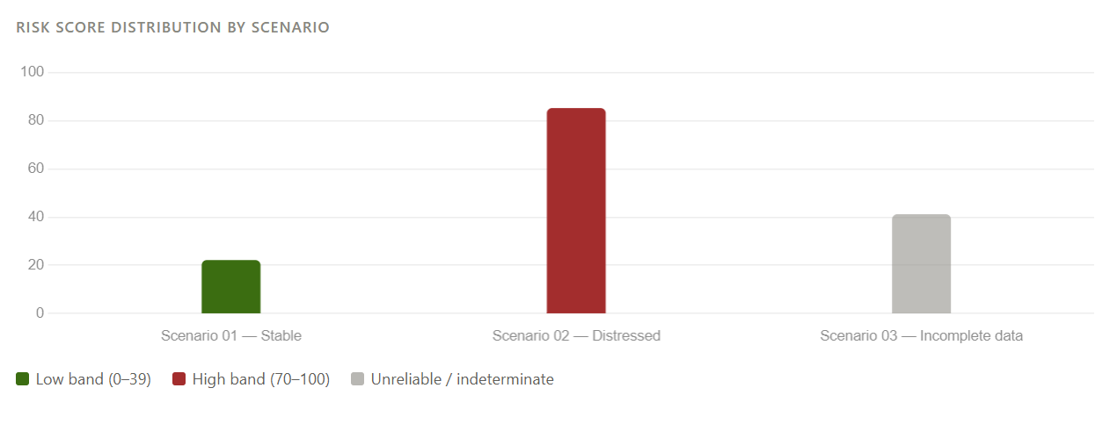
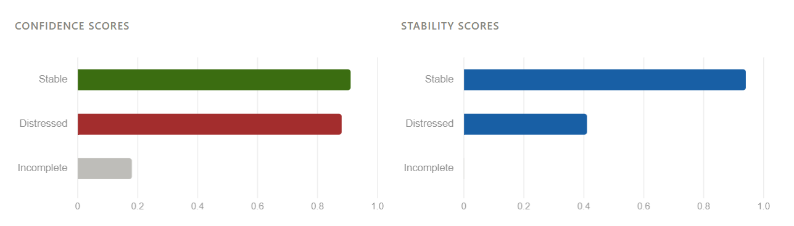

6. Key Insights

Rule-based model reliably identifies extreme cases
In Scenarios 01 and 02, the rule-based model correctly classified risk with high confidence (0.91 and 0.88). The deterministic logic produces auditable, driver-level explanations — making it well-suited to regulated environments where data quality is guaranteed.

M-Score is critical for manipulation scenarios the rule model misses
Scenario 03 illustrates the key complementarity: the rule model scored it only "Medium" (63) because headline financials looked acceptable. The M-Score and Isolation Forest caught the receivables inflation and CF/income divergence, elevating the final classification to "Hidden Risk."

Incomplete data causes cascading failure across all three model components

Scenario 03 exposed a systemic vulnerability: Isolation Forest aborted due to missing engineered features; M-Score was skipped with no receivables or COGS; the rule model produced a score (41) from fewer than half the expected signals. The combined confidence collapsed to 0.18 — correctly blocking automated action, but yielding no actionable verdict.

Stage 1 validation is the most important safeguard against data incompleteness
The validation stage correctly surfaced four warnings in Scenario 03: missing required columns, a null rate exceeding the 30% threshold, single-period lookback, and M-Score disabled status. These warnings propagated through the pipeline and were faithfully reflected in the final confidence score, preventing a false-verdict from reaching the report.

Pipeline modularity enables independent validation at every stage
The 6-stage pipeline (Validate → Prepare → Model → Validate → Insight → Report) passes structured JSON between stages, making it straightforward to unit-test each component and re-run partial pipelines on updated data without full reprocessing.

Critical Guardrails: Limitations of Financial Analysis
Even the most sophisticated forensic tools have inherent blind spots. To maintain data integrity, every analyst must respect these four limitations:
- Data Dependency: Risk scores are only as robust as the input. Missing data columns—specifically COGS and Receivables—silently reduce detection coverage, making the M-Score and manipulation detection impossible to compute.
- Peer Benchmarking: Scores are absolute, not industry-relative. A debt-to-equity of 2.5 is high-risk for a retailer but normal for a utility. Without sector-specific thresholds, false positives are possible in capital-intensive industries.
- Isolation forest "Cold Start": The anomaly model trains on the supplied dataset. With fewer than 10 companies or fewer than 3 historical periods per company, the contamination estimate may be unstable and anomaly scores unreliable.
- Forward-Looking Signals: These metrics are entirely backward-looking. They do not incorporate management guidance, market-implied signals, or credit rating changes that may precede a financial collapse.

